Drill and Ceremonies Armed Drill Team Commander
  - Job Description
The Armed Drill Team Commander is responsible for coordination of all events where the Armed Drill Team participates. The Armed Drill Team Commander will report directly to the Drill and Ceremonies Sq. Commander.

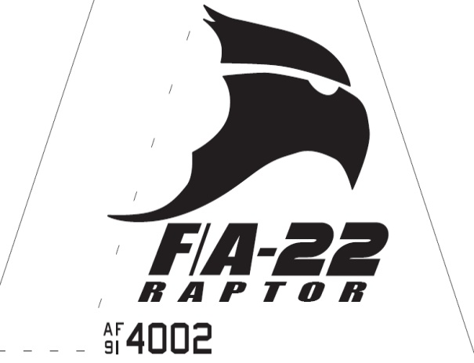Raptor Squadron
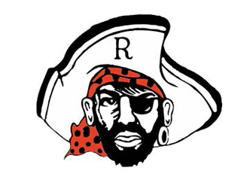

Drill and Ceremonies Armed Drill Team Commander
  - Job Description

Requirements
• • •
The Armed Drill Team Commander Position is normally assigned to a Junior Cadet (AS-2/AS-4), who displays leadership and communication skills necessary to manage all the tasks assigned to the position.
The minimum rank for this position is a Cadet 2nd Lieutenant
The minimum Aerospace Science (AS) level for this position is an AS-2
This position is highly recommended for cadets who possess the communication skills needed to provide educational presentations to a variety of audiences. Additionally, such cadet must be able to represent the AFJROTC program as a primary ambassador to the mission.
- The Armed Drill Team Commander must be able to keep proper discipline, maintaining their uniform and keeping proper grooming always to lead by example. They must also be able to delegate different tasks throughout their flight without causing any problems and confusion.
- The Armed Drill Team Commander is responsible for assisting the Drill and Ceremonies Commander in accomplishing Corps goals by preparing cadets for special public appearances.
- Responsible for setting up schedules and the training of all Armed Drill Team members. Supervises rehearsals.
- Coordinates the Armed Drill Team schedule with SASI/ASIs and recommends cadets for Armed Drill Team duty.
- Ensures Cadet Permission slips are coordinated through Mission Support personnel.
- Ensures Armed Drill Team records are updated with community service hours.
- Recruits cadets for Armed Drill Team duties.
- Keep Drill and Ceremonies Squadron Commander, Superintendent, SASI, and ASIs informed of any upcoming events or projects in your agenda.
- Coordinate with appropriate units for support when events are scheduled.
- Responsible with ensuring all events with Armed Drill Team requirements are properly planned and manned.
- Coordinates with Logistics Squadron personnel all Armed Drill Team uniform and equipment requirements.

