Armory Commander
  - Job Description
The Cadet Armory Commander is responsible in assisting the Drill and Ceremonies Squadron Commander with all section operations to support drill teams.

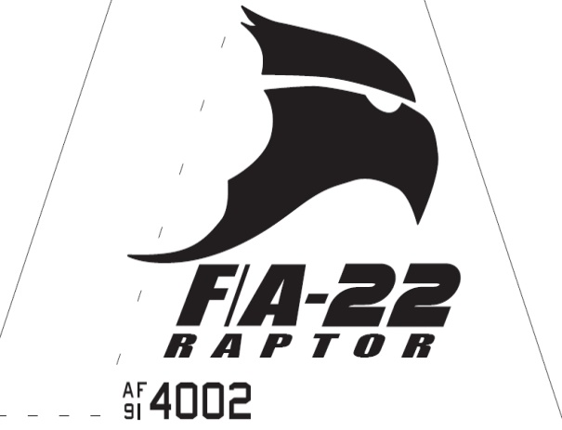Raptor Squadron

Armory Commander
  - Job Description

Requirements
• • •
The Armory Commander Position is normally assigned to a Junior Cadet (AS-2/AS-3), who displays leadership skills necessary to manage all the tasks assigned to the position.
The minimum rank for this position is a Cadet Second Lieutenant
The minimum Aerospace Science (AS) level for this position is an AS-2 who is familiar with the operations of the Armory
This position is highly recommended for cadets who have successfully completed at least one level of Cadet Leadership training and who have held a leadership position during the previous years.
The Armory Commander must lead by example in all areas.
- Takes charge of armory when designated Drill and Ceremonies Squadron Commander is unavailable.

- Helps schedule armory workers.
- Creates efficient and productive work schedules.
- Delegates workers in armory to effectively get the job done.
- Trains newly hired armory specialist in all operations within the section.
- Enforces armory rules and procedures.
- Maintains a clean and organized armory.
- Helps provide any armory equipment for practices and events.
- Ensures maintenance on equipment is performed properly when needed and advices Logistics Commander when supplies/parts are needed.
- Assists coordination for events related to Drill & Ceremonies.
- Responsible with safeguarding all armory equipment. Ensures armory is properly closed every morning and afternoon before AFJROTC closes.
- Conducts monthly inventories on all accountable equipment and reports findings to D&C and Logistics Squadron Commanders.

