Armory Sergeant
  - Job Description
The Cadet Armory Sergeant is responsible in assisting the Drill and Ceremonies Squadron Commander with all section operations to support drill teams.

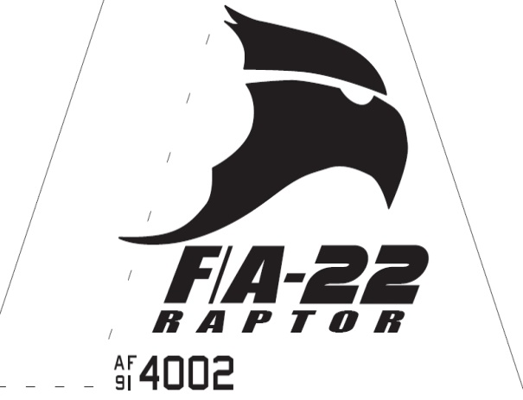Raptor Squadron

Armory Sergeant
  - Job Description

Requirements
• • •
The Armory Sergeant Position is normally assigned to a Junior Cadet (AS-2/AS-3), who displays leadership skills necessary to manage all the tasks assigned to the position.
The minimum rank for this position is a Cadet Staff Sergeant
The minimum Aerospace Science (AS) level for this position is an AS-2
This position is highly recommended for cadets who have successfully completed at least one level of Cadet Leadership training and who have held a leadership position during the previous years.
The Armory Sergeant must lead by example in all areas.
- Takes charge of armory when designated Armory Commander is out.

- Helps schedule armory workers.
- Creates efficient and productive work schedules.
- Delegates workers in armory to effectively get the job done.
- Trains newly hired armory specialist in all operations within the section.
- Enforces armory rules and procedures.
- Maintains a clean and organized armory.
- Helps provide any armory equipment for practices and events.
- Ensures maintenance on equipment is performed properly when needed and advices Logistics Commander when supplies/parts are needed.
- Assists coordination for events related to Drill & Ceremonies.
- Responsible with safeguarding all armory equipment. Ensures armory is properly closed every morning and afternoon before AFJROTC closes.
- Conducts monthly inventories on all accountable equipment and reports findings to Armory Commander.

