Armory Specialist
  - Job Description
The Armory Specialist is responsible in assisting the Armory Sergeant with section operations. The Armory Specialist will ensure all equipment is properly maintained and ready to support Drill and Ceremonies events.

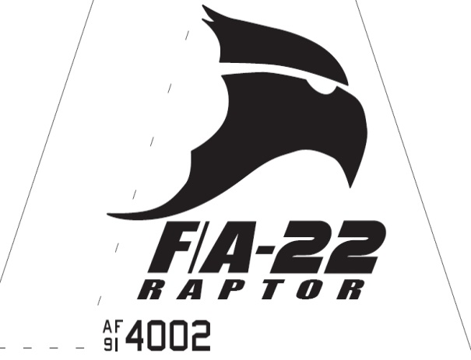Raptor Squadron
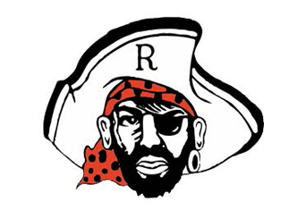

Armory Specialist
  - Job Description

Requirements
• • •
The Armory Specialist Position is normally assigned to a Junior Cadet (AS-1/AS-3), who displays leadership skills necessary to manage all the tasks assigned to the position.
The minimum rank for this position is a Cadet Airman
The minimum Aerospace Science (AS) level for this position is an AS-1
This position is highly recommended for cadets who possess organizational skills necessary to accomplish the mission of the armory section.
The Armory Specialist must follow specific guidance provided by leadership and excel in all areas.
- Assists Armory leadership by ensuring all equipment is properly maintained.

- Follows tasks assigned by Armory commander.
- Enforces armory rules and procedures.
- Maintains a clean and organized armory.
- Helps provide any armory equipment for practices and events.

- Ensures maintenance on equipment is performed properly when needed and advices Armory Commander when supplies/parts are needed.

- Assists coordination for events with Drill & Ceremonies staff.

- Responsible with safeguarding all armory equipment. Ensures armory is properly closed every morning and afternoon before AFJROTC closes.

- Conducts monthly inventories on accountable equipment and reports findings to Armory Sergeant.

