Drill and Ceremonies Squadron Color Guard Commander
  - Job Description
The Color Guard Commander is responsible for coordination of all events where Color Guard teams participate. The Color Guard Commander will report directly to the Drill and Ceremonies Sq. Commander.

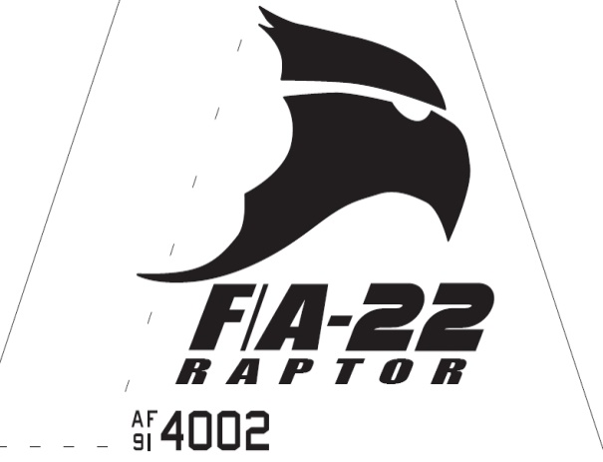Raptor Squadron

Drill and Ceremonies Squadron Color Guard Commander
  - Job Description

Requirements
• • •
The Color Guard Commander Position is normally assigned to a Junior Cadet (AS-2/AS-4), who displays leadership and communication skills necessary to manage all the tasks assigned to the position.
The minimum rank for this position is a Cadet 2nd Lieutenant
The minimum Aerospace Science (AS) level for this position is an AS-2
This position is highly recommended for cadets who possess the communication skills needed to provide educational presentations to a variety of audiences. Additionally, such cadet must be able to represent the AFJROTC program as a primary ambassador to the mission.
- The Color Guard Commander must be able to keep proper discipline, maintaining their uniform and keeping proper grooming always to lead by example. They must also be able to delegate different tasks throughout their flight without causing any problems and confusion.
- The Color Guard Commander is responsible for assisting the Drill and Ceremonies Commander in accomplishing Corps goals by preparing cadets for special public appearances.
- Responsible for setting up schedules and the training of all Color Guard members. Supervises rehearsals.
- Coordinates the Color Guard schedule with SASI/ASIs and recommends cadets for Color Guard duty.
- Ensures Cadet Permission slips are coordinated through Mission Support personnel.
- Ensures Color Guard records are updated with community service hours.
- Recruits cadets for Color Guard duties.
- Keep Drill and Ceremonies Squadron Commander, Superintendent, SASI, and ASIs informed of any upcoming events or projects in your agenda.
- Coordinate with appropriate units for support when events are scheduled.
- Responsible with ensuring all events with Color Guard requirements are properly planned and manned.
- Coordinates with Logistics Squadron personnel all Color Guard uniform and equipment requirements.

