Drill & Ceremonies Squadron Commander
  - Job Description
The Cadet Drill and Ceremonies Squadron Commander is responsible for the overall participation and training of squadron cadets. Such cadet is the liaison between the Drill & Ceremonies Squadron Staff, the Group Commander, and SASI/ASI.

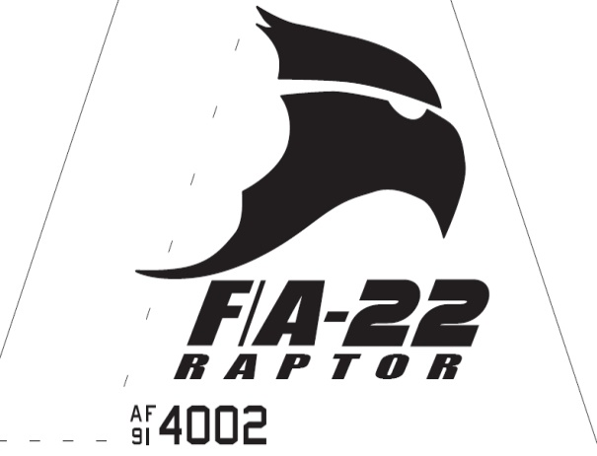Raptor Squadron
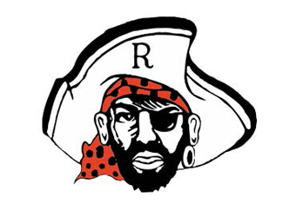

Drill & Ceremonies Squadron Commander
  - Job Description

Requirements
• • •
The Drill & ceremonies Squadron Commander Position is normally assigned to a Senior or Junior Cadet (AS-2/AS-4), who displays leadership skills necessary to manage all the tasks assigned to the position.
The minimum rank for this position is a Cadet Captain
The minimum Aerospace Science (AS) level for this position is an AS-2
This position is highly recommended for cadets who have successfully completed at least one level of Cadet Leadership training and who have held a leadership position during the previous years.
The Cadet Drill & Ceremonies Squadron Commander must lead by example in all areas.
- As the Drill & Ceremonies Squadron Commander, you must hold yourself and your staff to the highest standard. NO EXCUSES. The D&C Squadron is the ambassador of the program to all outside agencies and therefore represents what our program is about.
- Responsible for training, scheduling, and supervising all squadron teams.
- Responsible for establishing and maintaining written team policies and guidance (Standard Operating Procedures – SOPs) and providing a copy to the SASI/ASI.
- Responsible for maintaining a Drill & Ceremonies Binder, which includes policies and procedures, team guidance, rosters, etc.
- Coordinates and communicate with the Operations Squadron Commander on all team activities and upcoming events where D&C Teams are involved.
- Establishes an event calendar and ensures proper coordination and planning takes place.
- Establishes practice schedules for all drill teams.
- Maintains accurate records of each team member’s practices, performances, and community service hours.
- Responsible for maintaining equipment records, inventories, and notifying when supplies are needed to SASI/ASI.
- Schedules and prepares drill team members for drill meets. Researches and develops exhibition drill performances.
- Leads the cadet drill teams in ceremonial functions.
- Builds and leads Cadet Recruiting in coordination with Top Staff, APT and Planning Officers, to visit feeder schools.
- Recruits qualified cadet drill team members.
- Ensures Teams’ morale is maintained at a high with conflict resolution performed in a professional manner.
- Must attend all staff meetings or ensure squadron representation is present.
- Conducts staff meetings on a regular basis.
- Provide all resources needed by staff to complete their duties.
- Delegates tasks to all team leaders and armory personnel.
- Coordinates with Logistics Squadron staff to ensure all personnel have adequate uniform equipment readily available, fitted for upcoming competitions.
- Ensures teams are properly manned to provide support for events when needed.
- Provides task lists to all leadership personnel within squadron.

