Drill & Ceremonies Squadron Superintendent
  - Job Description
The Cadet Drill and Ceremonies Squadron Superintendent is responsible for assisting the commander with the overall participation and training of squadron cadets. Such cadet is the liaison between the Drill & Ceremonies Squadron Staff, the D&C Commander, and SASI/ASI.

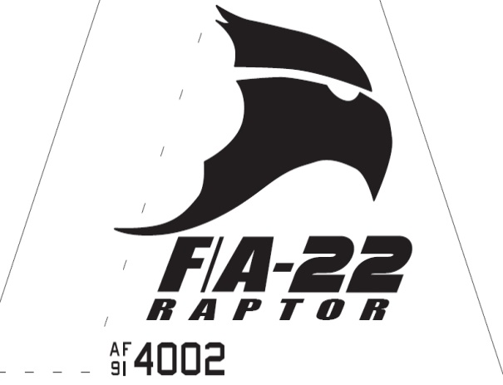Raptor Squadron
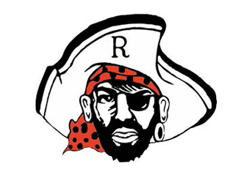

Drill & Ceremonies Squadron Superintendent
  - Job Description

Requirements
• • •
The Drill & ceremonies Squadron Commander Position is normally assigned to a Senior or Junior Cadet (AS-2/AS-4), who displays leadership skills necessary to manage all the tasks assigned to the position.
The minimum rank for this position is a Cadet Master Sergeant
The minimum Aerospace Science (AS) level for this position is an AS-2
This position is highly recommended for cadets who have successfully completed at least one level of Cadet Leadership training and who have held a leadership position during the previous years.
The Cadet Drill & Ceremonies Squadron Commander must lead by example in all areas.
- As the Drill & Ceremonies Squadron Superintendent, you must hold yourself and the rest of the staff to the highest standard. NO EXCUSES. The D&C Squadron is the ambassador of the program to all outside agencies and therefore represents what our program is about.
- Assist Sq. Commander with the training, scheduling, and supervising all squadron teams.
- Advises D&C Commander on policies and guidance (Standard Operating Procedures – SOPs).
- Assists in maintaining a Drill & Ceremonies Binder, which includes policies and procedures, team guidance, rosters, etc.
- Assists with coordination of drill team events with the Operations Squadron Commander on all team activities and upcoming events where D&C Teams are involved.
- Assists commander with scheduling practices for all drill teams and posts on practice board.
- Helps maintain accurate records of each team member’s practices, performances, community service hours, and merit points.
- Assists with the maintenance of equipment; records, inventories, and notifies when supplies are needed to SASI/ASI.
- Assists with schedules and prepares drill team members for drill meets. Researches and developing exhibiting drill performances.
- Assists with Cadet Recruiting in coordination with Top Staff, APT and Planning Officers, to visit feeder schools.
- Recruits qualified cadet drill team members.
- Ensures Teams’ morale is maintained at a high with conflict resolution performed in a professional manner.
- Must attend all staff meetings or ensure squadron representation is present.
- Provide all resources needed by staff to complete their duties.
- Delegates tasks to all team leaders and armory personnel.
- Coordinates with Logistics Squadron staff to ensure all personnel have adequate uniform equipment readily available, fitted for upcoming competitions.
- Ensures teams are properly manned to provide support for events when needed.
- Ensures Armory personnel maintains a work schedule and maintains all drill team equipment
- Coordinates with Armory staff to get drill team equipment ready.
- Assists commander with task lists provided to leadership within squadron.

