Drill and Ceremonies Squadron Honor Guard Sergeant
  - Job Description
The Honor Guard Sergeant assists the Honor Guard Commander with the coordination of all events where Honor Guard teams participate. The Honor Guard Sergeant will report directly to the Honor Guard Commander or D&C Sq. Commander.

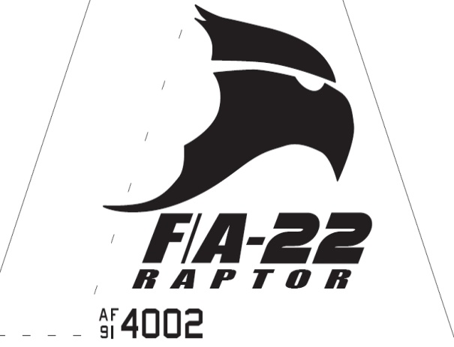Raptor Squadron
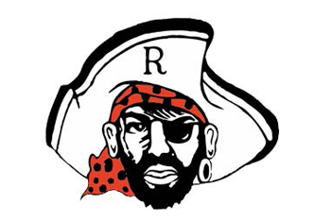

Drill and Ceremonies Squadron Honor Guard Sergeant
  - Job Description

Requirements
• • •
The Honor Guard Sergeant Position is normally assigned to a Junior Cadet (AS-2/AS-4), who displays leadership and communication skills necessary to manage all the tasks assigned to the position.
The minimum rank for this position is a Cadet Staff Sergeant
The minimum Aerospace Science (AS) level for this position is an AS-2
This position is highly recommended for cadets who possess the communication skills needed to provide educational presentations to a variety of audiences. Additionally, such cadet must be able to represent the AFJROTC program as a primary ambassador to the mission.
- The Honor Guard Sergeant must be able to keep proper discipline, maintaining his/her uniform and keeping proper grooming always to lead by example. They must also be able to delegate different tasks throughout their flight without causing any problems and confusion.
- The Honor Guard Sergeant is responsible for assisting the Honor Guard Commander in accomplishing Corps goals by preparing cadets for special public appearances.
- Assists setting up schedules and the training of all Honor Guard members. Supervises rehearsals.
- Helps coordinate Honor Guard schedule with Honor Guard Commander and Honor Guard members and recommends cadets for Honor Guard duty.
- Ensures Cadet Permission slips are coordinated through Mission Support personnel.
- Ensures Honor Guard records are updated with community service hours.
- Recruits cadets for Honor Guard duties.
- Keeps Honor Guard Commander, D&C Squadron Commander, Superintendent, SASI, and ASIs informed of any upcoming events or projects in your agenda.
- Helps coordinate with appropriate units for support when events are scheduled.
- Assists with ensuring all events with Honor Guard requirements are properly planned and manned.
- Coordinates with Logistics Squadron personnel all Honor Guard uniform and equipment requirements.

