Drill and Ceremonies Squadron Unarmed Drill Team Sergeant
  - Job Description
The Unarmed Drill Team Sergeant is responsible for coordination of all events where the Unarmed Drill Team participates. The Unarmed Drill Team Sergeant will report directly to the Unarmed Drill Team Commander.

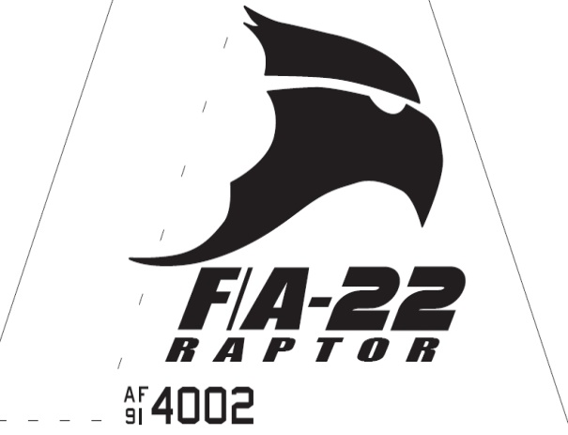Raptor Squadron
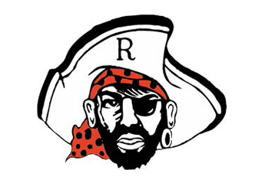

Drill and Ceremonies Squadron Unarmed Drill Team Sergeant
  - Job Description

Requirements
• • •
The Unarmed Drill Team Sergeant Position is normally assigned to a Junior Cadet (AS-2/AS-4), who displays leadership and communication skills necessary to manage all the tasks assigned to the position.
The minimum rank for this position is a Cadet Staff Sergeant
The minimum Aerospace Science (AS) level for this position is an AS-2
This position is highly recommended for cadets who possess the communication skills needed to provide educational presentations to a variety of audiences. Additionally, such cadet must be able to represent the AFJROTC program as a primary ambassador to the mission.
- The Unarmed Drill Team Sergeant must be able to keep proper discipline, maintaining their uniform and keeping proper grooming always to lead by example. They must also be able to delegate different tasks throughout their flight without causing any problems and confusion.
- The Unarmed Drill Team Sergeant assists the Unarmed Drill Team Commander in accomplishing Corps goals by preparing cadets for special public appearances.
- Assists with setting up schedules and the training of all Unarmed Drill Team members. Supervises rehearsals.
- Helps coordinates the Unarmed Drill Team schedule with SASI/ASIs and recommends cadets for Unarmed Drill Team duty.
- Ensures Cadet Permission slips are coordinated through Mission Support personnel.
- Ensures Unarmed Drill Team records are updated with community service hours.
- Recruits cadets for Unarmed Drill Team duties.
- Keeps Unarmed Drill Team Commander, Drill and Ceremonies Squadron Commander, Superintendent, SASI, and ASIs informed of any upcoming events or projects in your agenda.
- Coordinates with appropriate units for support when events are scheduled.
- Responsible with ensuring all events with Unarmed Drill Team requirements are properly planned and manned.
- Coordinates with Logistics Squadron personnel all Unarmed Drill Team uniform and equipment requirements.

